# **Day 23 Task**

## **Part 2: Estimating a Multi-Tier Architecture Solution**

**Scenario:** You need to design and estimate the cost for a scalable web application that includes a load balancer, a set of EC2 instances for the application tier, and an RDS database for the data tier. The solution must support a user base of up to 100,000 concurrent users.

**Steps:**

* Define the Architecture:
  + Identify the components required: an Application Load Balancer, EC2 instances for the application servers, and an RDS instance for the database.
  + Consider the expected traffic and choose appropriate EC2 instance types and RDS configurations.
* Select AWS Services:
  + Choose an Application Load Balancer to distribute incoming traffic.
  + Select EC2 instance types (e.g., t3.medium) that can handle the application load.
  + Choose an RDS instance type (e.g., db.m5.large) to support the database.
* Estimate Costs Using AWS Pricing Calculator:
  + Navigate to the AWS Pricing Calculator.
  + Add the Application Load Balancer, EC2 instances, and RDS instance to the estimate.
  + Configure each service based on the expected load and required specifications (e.g., storage, data transfer).
* Document and Analyze the Estimate:
  + Review the total estimated monthly cost.
  + Identify any areas where cost-saving measures could be applied (e.g., reserved instances, using Auto Scaling to optimize EC2 usage).
* Prepare a Report:
  + Compile the architecture design and cost estimate into a report.
  + Provide recommendations on how to maintain performance while optimizing costs, considering the expected growth and scalability needs of the application.

**Output:**

* **Application Load Balancer**

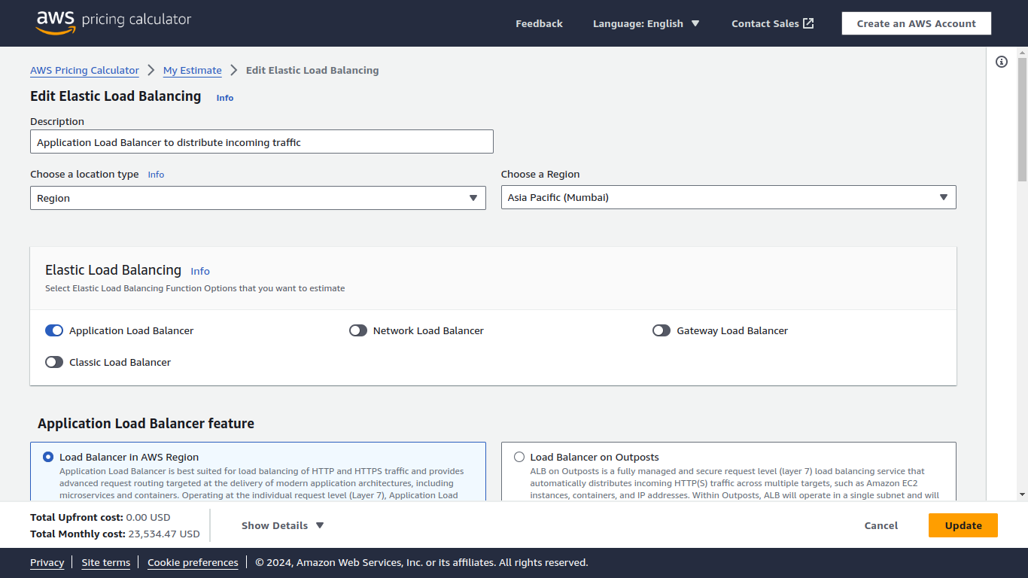

**EC2 instances for the application servers**

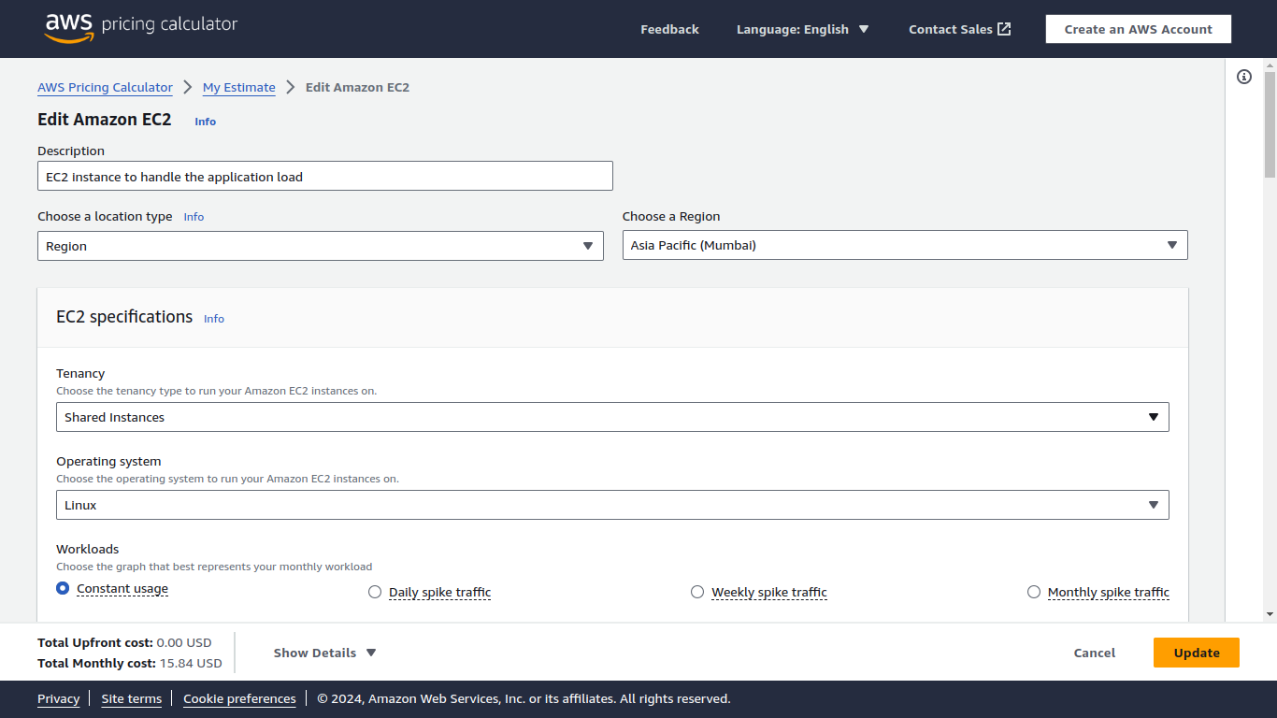

**RDS instance for the database**

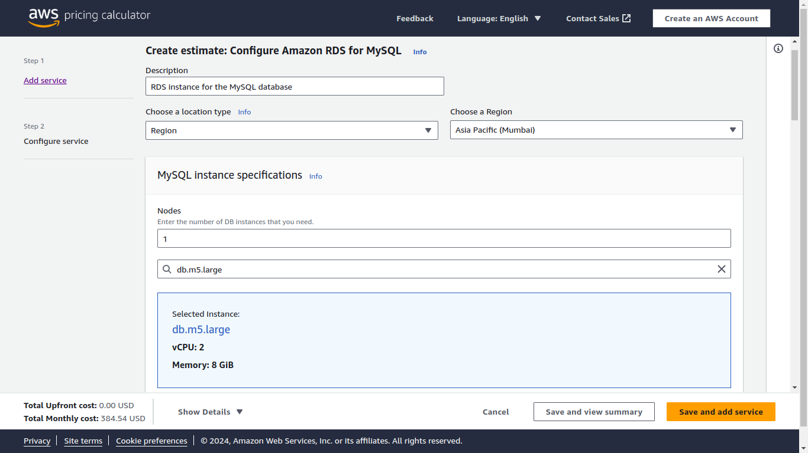

**Final Budget**

